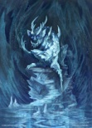
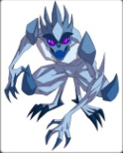
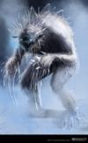
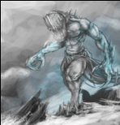
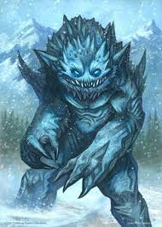
The Living Ice

Other Names: | Glacier Giants, Sliding Glaciers
Preferred Environment: | Arctic Tundra, Glacial Zones
Diet: | Carnivore; its prey usually mistakes the creature for a glacier
Special Ability: | Chameleon; blends into large glacial forms (appearing as a crack in the ice) to get the drop on unsuspecting victims
Short Range Attack: | Claw Slash; creature attacks with its ice-pick like claws
Long Range Attack: | Ice Throw; creature flicks its hands causing its claws to detach and fly towards the opposing creature
Special Attack: | Ambush Throw; creature blends from chameleon form and lifts the adventurer into the air and then throws him down
Immunities: | Large Immunity to Ice-based weaponry or spells
Weaknesses: | Large Weakness to fire-based weaponry or spells
Movement Speed: | The creature moves at a very slow pace while patrolling around ambush points. When in range of an adventurer, the creature either blends into a nearby glacier or breaks into a sliding run to catch the adventurer before he has a chance to escape. If blending, the creature waits until the adventurer is within range of the special attack before springing the trap
Visual Description: | Made solely of ice. This giant is a sight to behold. Marked by a large body mass with skinny ice arms protruding in a way that is reminiscent of natural ice formations. It’s as if this creature was crafted by a flow of water that froze and suddenly came to life. The ends of the arms branch to sharp ice shards that double as claw-like weapons and disconnect for ranged attacks. The creature mainly lumbers slowly with its large snow shoe-esque feet barely leaving the ground. When running the creature appears to skate across the ice. The head is similar to the rest of the body in that it ends in jaggy icicles. In some of these creatures this creates the jaggy appearance of a beard, in others the appearance of spiky hair. A dominating feature is the red eyes that appear to pierce the sole of adventurers. The mouth on the creature is rather small, requiring the beast to devour his prey slowly and in pieces. The mouth is filled with small icicle-sharp teeth.
Proportions: | Large flat feet, long skinny legs, upper body a little over half the height of the legs, wide upper body with the shoulder width extending beyond the width of the knees, long skinny arms with wrists occurring below the waist line, large hands with long claw-like fingers, head about the same size as the hands, but with a pentagonal shape, icicles of varying length protrude from the back of the head or chin
General Dimensions (Bind Pose): | ~3.7 meters tall, ~6 meters wide in T pose, ~1 meter deep

