12
11
10
9
Tearmann Baile

11
12
10
9
Saol Falls

The Aigead Wastes

Tarragon’s Bridge

8
7
6
5
5
6
7
8
Dragon Boneyard

Graveyard of Speir

Ceo Cathair

The Path of Speir

4
The Gates of Speir

4
3
2
1
3
Uphiminn Bridge

2
Ruins of Minteras

1
Grunnr Village

Inis Speir
Points of Interest

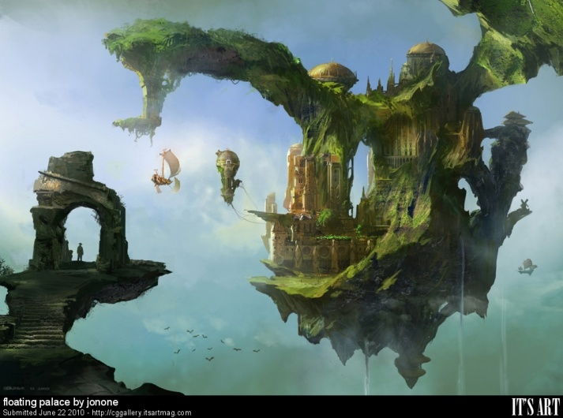
History
Inis Speir was once a grand and beautiful land. Known far and wide for its floating cities in the sky, Inis Speir was the home of the legendary Dragon Riders. Dragon Riders raised dragons from birth and used them as a means of transportation between their vast islands in the sky. Isolationists, up until the time of Opening, the Dragon Riders mainly kept to themselves in the sky, with no means of access given to the ground walkers. During the time of Opening the Dragon Riders decided to build a city on the Isle of Minteras as a way to open trade to the ground walkers (later known as the Gadai). To maintain security, Minteras was built to be a landing dock for the Dragon Riders, with their main land, Cathair, still accessible via dragon flight alone. After the time of Opening the Dragon Riders saw a period of economic growth and cultural expansion. All seemed well, but things are not always as they seem. Unknown to the Dragon Riders, the Gadai had begun contemplating a plan for usurping the isles, as the Gadai considered the isles the lands of their gods (Uphiminn). On a historically dark night, the Gadai staged their attack, beginning with the placement of the Uphiminn Bridge which allowed access to the core of Inis Speir, Ceo Cathair. The Gadai attacked the nesting roost of the dragons first, slaying all they could find from hatchlings to the full grown in their sleep. The Dragon Riders, having relied on their safety in the skies for millennia, were quickly overrun and destroyed by the Gadai. The land, however, was spiritually tied to the dragons and with their destruction it quickly began to fall into decay. This decay unleashed an ancient corruption demon. Many of the Gadai, sensing the great evil they had unleashed fled back to Grunnr Village. The few that remained became corrupted and now walk the lands in a range of decaying forms.

Points of Interest

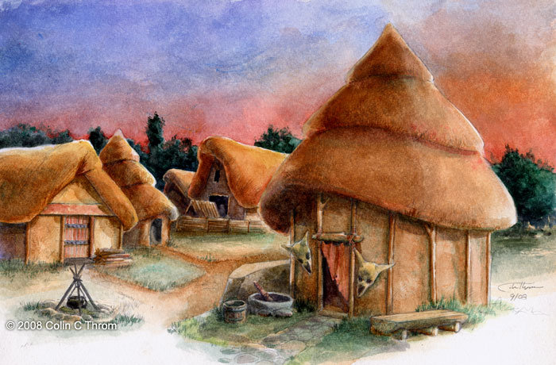
Village of the Gadai / Grunnr Village
1
Known as the Village of the Gadai to the Dragon Riders and Grunnr Village to the Gadai, this small village emanates a sense of regret. The Gadai recognize the great evil that spawned from their greed for the Isles of the Sky. They now live in their small, rural huts, trying their best to atone and correct the evil their people committed. They strive for simplicity and minimalism in architecture and belongings, with the idea that less in the material world evades the evils of greed. They spiritually believe that simplicity is the only way their gods will forgive them for attempting to take from Uphimminn.

Ruins of Minteras
2
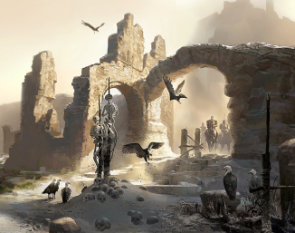
Minteras was once a shining city of trade between the Dragon Riders and the Gadai. Entrance to the city was provided by a cobblestone path leading from the mountain range upon which Grunnr village sits to the floating Isle of Minteras. At the north end of Minteras was a grand castle, designed to have flight entrance from the rear for dragon landings. This great tower of Minteras was a sight to behold when in its full stature. Today naught but ruins remain on the Isle of Minteras. As the first stop of the Gadai’s invasion force, Minteras was torn to the ground leaving only rubble and ash. A haunting sense of emptiness blows through the ruins with a feint hint of longing for the past on the tips of every breeze.
3

Bridge of the Gadai / Uphiminn Bridge
Known as the Bridge of the Gadai to the Dragon Riders and the Uphiminn Bridge to the Gadai, this was the bridge to heaven built by the Gadai to invade Inis Speir. This great bridge of little more than wooden brambles, allowed the Gadai forces access to the relatively unprotected inner lands of Inis Speir.
4

The Gates of Speir / Uphiminn Gate
Known as the Gates of Speir to the Dragon Riders, and Uphiminn Gate to the Gadai, these were not gates in the traditional sense, but pillars. The welcoming pillars soared high into the sky for triumphant dragons to encircle on their descent to the celebratory crowds below when a successful venture had taken place. They marked the beginning of the Path of Speir and the edge of Inis Speir. Today, these gates still stand, amidst destruction, as a testament to the grandeur of the Dragon Riders.
7

The Path of Speir / Bani Road
The Path of Speir was the Dragon Rider’s main road through Inis Speir. During its height, the Path of Speir was surrounded by trees and all manner of greenery. The path itself glowed with what some would call a magical luminescence. Today, the path sits in a barren land of decay. The Gadai call this Bani Road to reflect the shame they feel for the great horrors they committed along the road.
5

Dragon Boneyard
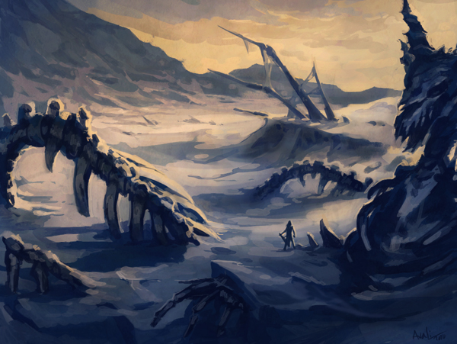
The Dragon Boneyard was once a nesting and training ground for the Dragon Rider’s dragons. The Dragon Riders would raise them from hatchlings and train them for recon, battle, and travel. Today, one would barely recognize the once fruitful grounds. Carcasses of great dragons, long forgot, now fill the land. Whispers of dragon spirits walking these areas in search of the freedom of the skies in which they will never again soar are commonly heard in Gadai villages.

Graveyard of Speir
6
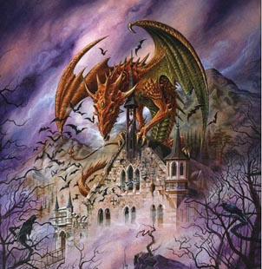
Just north of the Dragon Boneyard is the Graveyard of Speir. Originally chosen by the Dragon Riders as a place to honor their dead; during the invasion by the Gadai, this area became a combination graveyard and mass burial ground. A dreadfully haunted area, it is here that the lost souls of the Dragon Riders fight endlessly in a losing battle against the Gadai. Wondering travelers should be wary to not get caught up in the battle that ensues between the ghosts and the remaining corrupted Gadai.
8

Ceo Cathair
During the great battle for Inis Speir, this was the last stronghold of the Dragon Riders. Protected by the great dragon Tarragon, it was no easy feat for the Gadai to fell the beast and take control of Ceo Cathair. It was through the strength of an ancient evil that allowed the Gadai to raise corruption demons and gain the competitive edge needed to conquer Ceo Cathair. The pact with the corruption demons back fired, however, and instead of conquering and ruling from Ceo Cathair, the Gadai were instead slowly transformed, along with the land, into corrupted beings. Today Ceo Cathair is home to all manner of corrupted Gadai.
9

The Aigead Wastes
The Aigead Wastes is the center of the corruption in Inis Spear. A bubbling lake of acidic waters, it is here that a corruption demon sat in waiting underground for millennia. The demon was kept at bay due to a magical trait of dragons that forced the demon into hiding. As the Gadai invaded and slew the majority of the dragons, the demon found his long awaited opportunity to escape. He then leveraged the Gadai to assist in destroying the dragons forever. He quickly turned on the Gadai converting those who could not escape into corrupted minions. He then spread corruption throughout Inis Speir.
10

Tarragon’s Bridge
Tarragon’s bridge is actually Tarragon’s final resting place. Falling from the sky during the final battle for Ceo Cathair, Tarragon’s enormous body fell between the central Isle of Inis Speir and the Isle of Tearmann Baile. To cross this “bridge” one must enter the mouth of the grand dragon and travel up his rib cage to the Isle above. Fear of accidentally awaking the beast through some unnatural means, keeps the corruption demon and his minions from approaching the “bridge”.
12
11

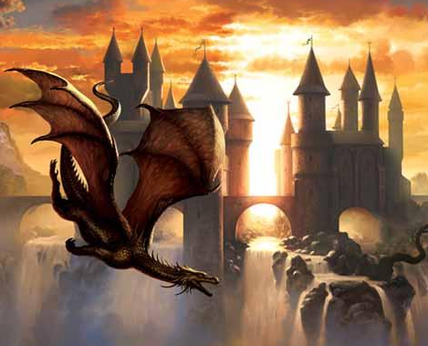
Tearmann Baile
Tearmann Baile is the home of the descendants of the last Dragon Riders. Living in a small tower they have formed a place to preserve their history. Harnessing what they can from the remains of Tarragon, they have created a small utopian area, free from corruption with their crowning achievement being Saol Falls. They want nothing more than to free their lands from the hands of the corruption demon.

